RECRUITMENT WORKFLOW
Detailed Process Documentation
Based strictly on the supplied Recruitment Workflow image
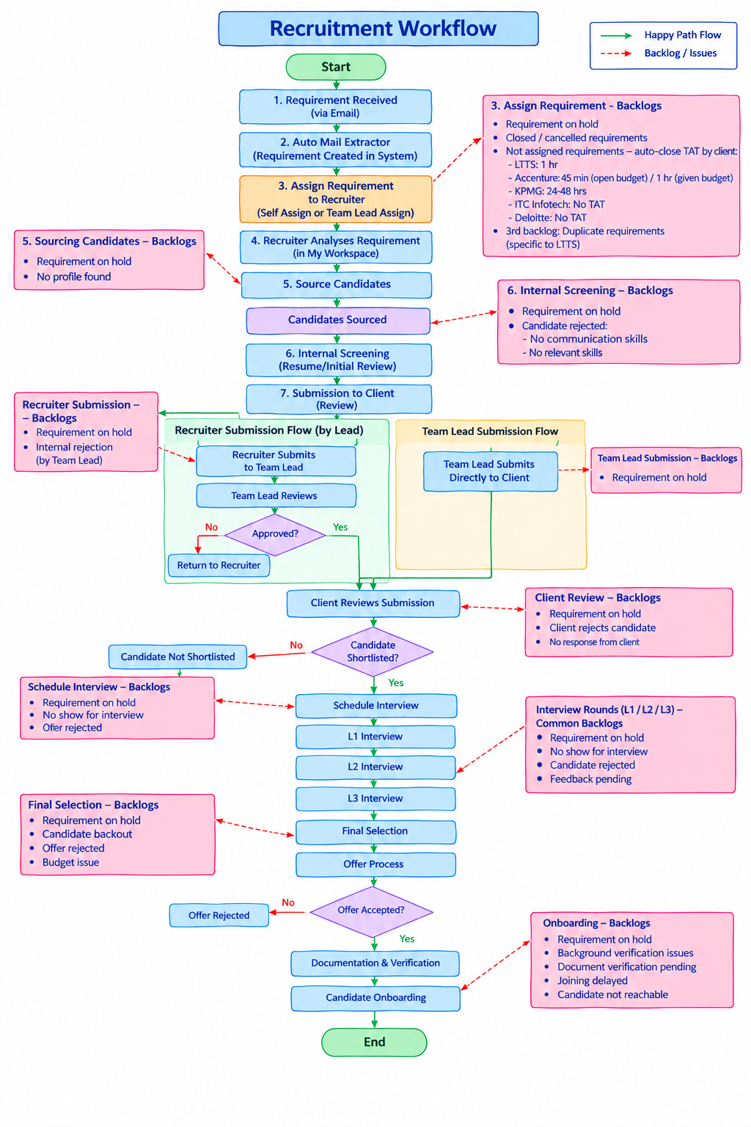

1. Document Purpose
This document describes the recruitment workflow shown in the supplied diagram from Start to End. It records the main process, decision points, submission routes, interview stages, offer flow, onboarding flow, and the backlog/issues explicitly listed in the diagram. The descriptions below follow the image and do not add new business rules that are not represented in it.

2. Workflow Legend
Happy Path Flow: The green arrows represent the normal forward movement of the recruitment process.
Backlog / Issues: The red dashed arrows point from workflow stages to operational backlog or issue conditions.

3. End-to-End Recruitment Workflow
Start
The recruitment workflow begins.
1. Requirement Received (via Email)
A recruitment requirement is received through email.
2. Auto Mail Extractor (Requirement Created in System)
The auto mail extractor processes the incoming email and creates the requirement in the system.
3. Assign Requirement to Recruiter (Self Assign or Team Lead Assign)
The requirement is assigned to a recruiter. The diagram specifies two assignment methods: self-assignment or assignment by the Team Lead.
4. Recruiter Analyses Requirement (in My Workspace)
The recruiter analyses the requirement in the recruiter workspace before starting candidate sourcing.
5. Source Candidates
The recruiter sources candidates against the requirement.
Candidates Sourced
The sourced candidate pool moves to internal screening.
6. Internal Screening (Resume/Initial Review)
The recruiter performs resume/initial screening of sourced candidates.
7. Submission to Client (Review)
After internal screening, the candidate moves to the client submission/review stage.

4. Requirement Assignment – Backlogs
The diagram identifies the following backlog/issue conditions at the requirement-assignment stage:
- Requirement on hold.
- Closed / cancelled requirements.
- Not assigned requirements – auto-close TAT by client.
Auto-close TAT details shown in the workflow:
Client | Auto-close TAT shown
LTTS | 1 hr
Accenture | 45 min (open budget) / 1 hr (given budget)
KPMG | 24–48 hrs
ITC Infotech | No TAT
Deloitte | No TAT
Additional backlog shown: 3rd backlog – Duplicate requirements (specific to LTTS).

5. Sourcing Candidates – Backlogs
- Requirement on hold
- No profile found

6. Internal Screening – Backlogs
The diagram lists two categories of backlog/issue at internal screening:
- Requirement on hold
- Candidate rejected
For a rejected candidate, the diagram specifies:
- No communication skills
- No relevant skills

7. Submission to Client – Two Submission Routes
After the internal screening stage, the workflow branches into two submission routes.

7.1 Recruiter Submission Flow (by Lead)
- Recruiter submits to Team Lead.
- Team Lead reviews the submission.
- The workflow reaches the “Approved?” decision.
If Approved = Yes:
- The submission proceeds to Client Reviews Submission.
If Approved = No:
- The candidate is returned to the recruiter.
Backlogs shown for Recruiter Submission:
- Requirement on hold
- Internal rejection (by Team Lead)

7.2 Team Lead Submission Flow
- Team Lead submits directly to the client.
- The submission then proceeds to Client Reviews Submission.
Backlog shown for Team Lead Submission:
- Requirement on hold.

8. Client Review
The client reviews the submitted candidate.
The workflow contains the decision: “Candidate Shortlisted?”
If Yes:
- The candidate proceeds to Schedule Interview.
If No:
- The candidate moves to Candidate Not Shortlisted.
Client Review backlogs shown in the diagram:
- Requirement on hold
- Client rejects candidate
- No response from client

9. Schedule Interview
A shortlisted candidate proceeds to interview scheduling.
Schedule Interview backlogs shown:
- Requirement on hold
- No show for interview
- Offer rejected

10. Interview Rounds
The normal interview sequence shown in the diagram is:
- L1 Interview
- L2 Interview
- L3 Interview
- Final Selection
- Offer Process
Common backlogs for Interview Rounds (L1 / L2 / L3):
- Requirement on hold
- No show for interview
- Candidate rejected
- Feedback pending

11. Final Selection
After the interview rounds, the candidate reaches Final Selection and then proceeds to Offer Process.
Final Selection backlogs shown:
- Requirement on hold
- Candidate backout
- Offer rejected
- Budget issue

12. Offer Process and Offer Decision
The workflow proceeds from Final Selection to Offer Process.
The next decision is: “Offer Accepted?”
If Yes:
- Documentation & Verification
- Candidate Onboarding
- End
If No:
- The candidate moves to Offer Rejected.

13. Onboarding
For an accepted offer, the candidate proceeds through Documentation & Verification and then Candidate Onboarding.
Onboarding backlogs shown:
- Requirement on hold
- Background verification issues
- Document verification pending
- Joining delayed
- Candidate not reachable

14. Complete Happy-Path Sequence
Start → Requirement Received (via Email) → Auto Mail Extractor → Requirement Created in System → Assign Requirement to Recruiter → Recruiter Analyses Requirement → Source Candidates → Candidates Sourced → Internal Screening → Submission to Client → Recruiter Submission Flow by Lead OR Team Lead Submission Flow → Client Reviews Submission → Candidate Shortlisted → Schedule Interview → L1 Interview → L2 Interview → L3 Interview → Final Selection → Offer Process → Offer Accepted → Documentation & Verification → Candidate Onboarding → End.

15. Decision-Point Summary
Decision Point | Yes / Positive Path | No / Alternative Path
Approved? | Proceed to Client Reviews Submission | Return to Recruiter
Candidate Shortlisted? | Schedule Interview | Candidate Not Shortlisted
Offer Accepted? | Documentation & Verification → Candidate Onboarding | Offer Rejected

16. Backlog / Issue Summary
Workflow Stage | Backlogs / Issues Shown
Assign Requirement | Requirement on hold; closed/cancelled requirements; not assigned requirements; client-specific auto-close TAT; duplicate requirements specific to LTTS.
Source Candidates | Requirement on hold; no profile found.
Internal Screening | Requirement on hold; candidate rejected due to no communication skills or no relevant skills.
Recruiter Submission | Requirement on hold; internal rejection by Team Lead.
Team Lead Submission | Requirement on hold.
Client Review | Requirement on hold; client rejects candidate; no response from client.
Schedule Interview | Requirement on hold; no show for interview; offer rejected.
Interview Rounds | Requirement on hold; no show for interview; candidate rejected; feedback pending.
Final Selection | Requirement on hold; candidate backout; offer rejected; budget issue.
Onboarding | Requirement on hold; background verification issues; document verification pending; joining delayed; candidate not reachable.

17. Important Workflow Notes
- The workflow explicitly separates recruiter submission through a Team Lead from direct Team Lead submission to the client.
- Team Lead approval is a decision point only for the recruiter submission route shown.
- Client shortlisting determines whether the candidate proceeds to interview scheduling.
- The interview sequence shown is L1 → L2 → L3 → Final Selection → Offer Process.
- Offer acceptance leads to Documentation & Verification and Candidate Onboarding.
- Red dashed connections in the image represent backlog/issues associated with particular stages.
- The client-specific auto-close TAT values are shown under the assignment backlog section and should be treated as the values represented in the supplied workflow.
- The document preserves the workflow and backlog wording from the supplied image rather than introducing additional process rules.

18. Scope of This Document
This document is a detailed textual representation of the supplied Recruitment Workflow image. It is intended to provide a clear reference for understanding the process flow and the backlog conditions displayed in the diagram.

